Paper Title Maximum 16 Words ← 12pt, Times New Roman, Bold, Sentence case

Author 1^{a*}, Author 2^{b} ← 11pt, Times New Roman, Bold
^{a*}Name of University, Name of Province/State, Name of Country, Email ← 10pt
^{b}Name of University, Name of Province/State, Name of Country, Email ← 10pt

*Correspondence: corresponding author email ← 10pt

Abstract ← 11pt, Times New Roman, Bold  The abstract should be clear, concise, and descriptive. This abstract should provide a brief introduction to the problem, objective of paper, followed by a statement regarding the methodology and a brief summary of results. The abstract should end with a comment on the significance of the results or a brief conclusion. Abstracts are written in 11pt, Times New Roman preferably not more than 250 words. |  | Article History:  Keywords:

- Introduction← 12pt, Times New Roman, Bold
Introduction written in English with 11 pt, Times New Roman, 1 space. In the introduction, the first paragraph contains an explanation regarding the field of research and why the field of research study is important to study. In the introduction you must be able to represent the research problem, previous research and explain the differences between your research and the previous one. Therefore, you must be able to display the GAP research well. At the end you must present the purpose or formulation of the problem in this research.

- Method← 12pt, Times New Roman, Bold
The research method is written in English with 11 pt, Times New Roman, 1 space. In this section you at least present the research design used, research participants/research subjects/populations and samples, data collection, and data analysis.

Tables
Tables are sequentially numbered with the table title and number above the table. Tables should be centered in the column OR on the page. Tables should be followed by a line space (11pt). Elements of a table should be single-spaced, however double spacing can be used to show groupings of data or to separate parts within the table.
Table headings should be at 11pt. Tables are referred in the text by the table number. eg: Table 1. Do not show vertical lines in the table. There is only horizontal line should be shown within the table.
Table 1
Main Information
Description | Results
Timespan | 1978:2023
Sources (Journals, Books, etc) | 127
Documents | 241
Annual Growth Rate % | 7.22
Document Average Age | 3.37
Average citations per doc | 20.72
References | 1
Keywords Plus (ID) | 613
Author's Keywords (DE) | 687
Authors | 716
Authors of single-authored docs | 27
Single-authored docs | 27
Co-Authors per Doc | 3.48
International co-authorships % | 14.11
Article | 241

Equations
Equations should be numbered serially within parentheses as shown in Equation (1). Equation should be prepared using MS Equation Editor (not in image format). The equation number is to be placed at the extreme right side.
(1)

Figures
Figures are sequentially numbered commencing at 1 with the figure title and number below the figure as shown in Figure 1.
Figure 1
Footage of strengthening the value of the LCM

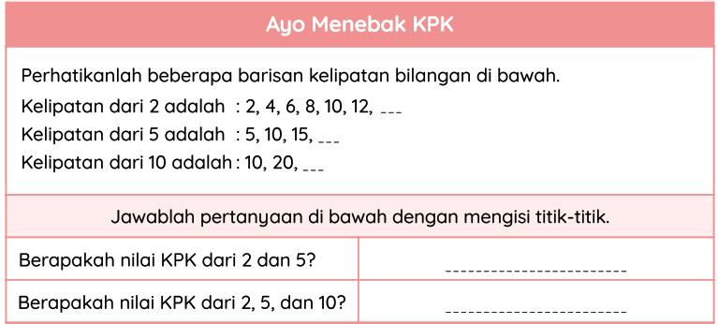

- Results and Discussion ← 12pt, Times New Roman, Bold
3.1 Results
Manuscript Heading, Font, and Spacing ← 11pt, Times New Roman, Bold. Manuscript should be typed using word processors (Microsoft Word or Open Office) software. The font used throughout the paper is Times New Roman. The paper size is A4 (i.e., 210 x 297 mm), one-column format with a 2.5 cm margin at the top, a 2.5 cm margin at the bottom, 2.5 cm margin on the left, and 2.5 cm margin on the right. Lines are 1 spaced, justified. Use of pronouns such as I, we etc is to be avoided.
Manuscript submitted to this journal should follow the heading below, except for the review article: Title; Authors Name; Authors Affiliation; Abstract; Keywords; Methods; Results and Discussion; Conclusions; Acknowledgments; and References.
Results should be clear and concise. The results should summarize (scientific) findings rather than providing data in detail. Please highlight differences between your results or findings and the previous publications by other researchers.
3.2 Discussion
The discussion should explore the significance of the results of the work, not repeat them. A combined Results and Discussion section is often appropriate. Avoid extensive citations and discussion of published literature.
In discussion, it is the most important section of your article. Here you get the chance to sell your data. Make the discussion corresponding to the results, but do not reiterate the results. Often should begin with a brief summary of the main scientific findings (not experimental results). The following components should be covered in discussion: How do your results relate to the original question or objectives outlined in the Introduction section (what)? Do you provide interpretation scientifically for each of your results or findings presented (why)? Are your results consistent with what other investigators have reported (what else)? Or are there any differences?

- Conclusion ← 12pt, Times New Roman, Bold
Conclusions should answer the objectives of research. Tells how your work advances the field from the present state of knowledge. Without clear Conclusions, reviewers and readers will find it difficult to judge the work, and whether it merits publication in the journal. Do not repeat the Abstract, or just list experimental results. Provide a clear scientific justification for your work and indicate possible applications and extensions. You should also suggest future experiments and/or point out those that are underway.

- References ← 12pt, Times New Roman, Bold

The main references are Books, International Journals, and Proceedings. All references should be to the most pertinent and up-to-date sources. References are written in APA 7 Style. Please use a consistent format for references – see examples below (11pt):

Book:
Ardi, D. S. (2018). Learning mathematics in a mobile app-supported math trail environment. Springer International Publishing. https://doi.org/10.1007/978-3-319-93245-3

Book that consists of some articles:
McKenney, S., & Reeves, T. C. (2014). Educational design research. In Spector J., Merrill M., Elen J., Bishop M. (Eds.), Handbook of Research on Educational Communications and Technology (pp. 131-140). Springer. https://doi.org/10.1007/978-1-4614-3185-5_11

Proceeding, Conference:
Hoch, M., & Dreyfus, T. (2006). Structure sense versus manipulation skills: An unexpected result. In J. Novotna, H. Moraova, M. Kratka, & N. Stehlikova (Eds.), Proceedings of the 30th Conference of the International Group for the Psychology of Mathematics Education (Vol. 3, pp. 305-312). Prague, Czech Republic: PME

Article in Journal:
Sudirman, A., Sispiyati, R., & Chin, K.E. (2021). An investigation of students’ algebraic proficiency from a structure sense perspective. Journal on Mathematics Education, 12(1), 147-158. http://doi.org/10.22342/jme.12.1.13125.147-158

